**Hands-On Assignments**

**Reviewing SQL and Data in the Brewbean's Database**

Becoming familiar with the Brewbean's database is important because it's used in examples and exercises. For this assignment, you create a few queries to review the data.

First, you query the database by following these steps:

1. Start SQL Developer and connect to Oracle.
2. Enter the query shown in Figure 1-22 below and check your data against the listing shown.

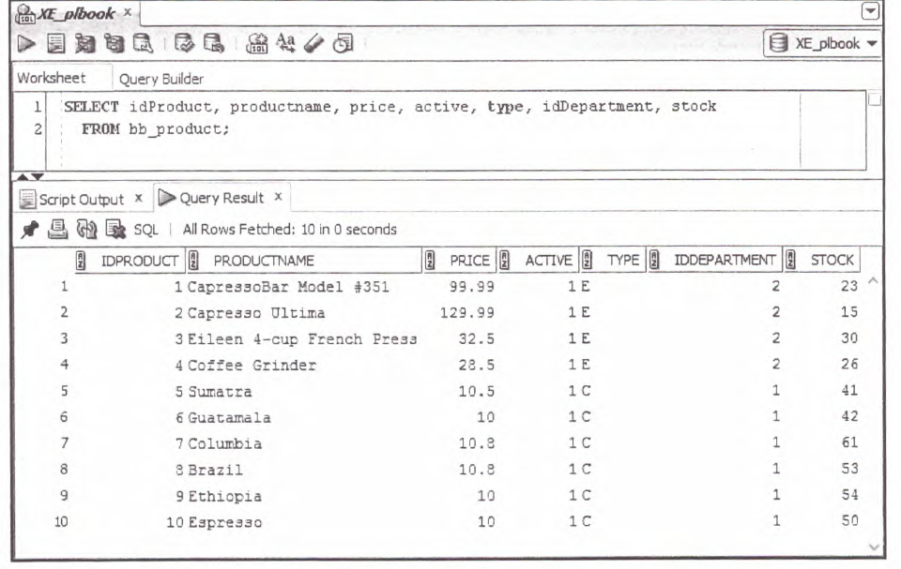

3. Enter the query shown in Figure 1-23 below and check your data against the listing shown.

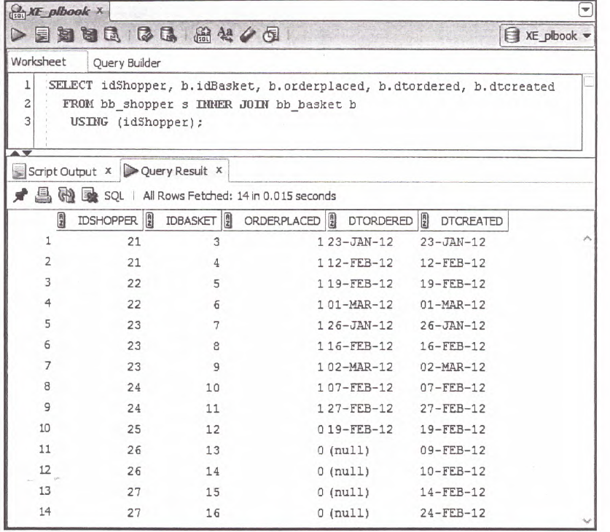

4 Enter the query shown in Figure 1-24 below and check your data for idProduct 5 and idProduct 6 against the listing shown. The full results should contain 24 rows of output.

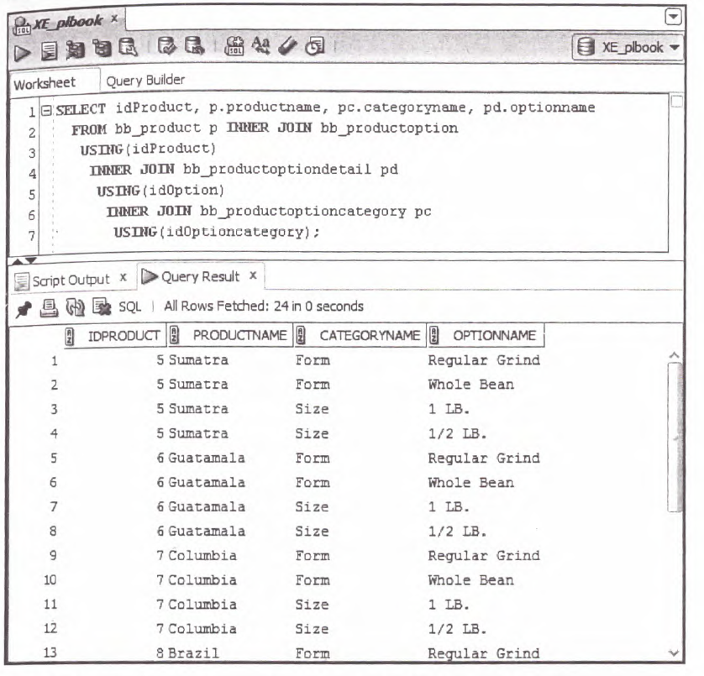

1. Produce an unduplicated list of all product IDs for all products that have been sold. Sort the list.
2. Show the basket ID, product ID, product name, and description for all items ordered. (Do it two ways—one with an ANSI join and one with a traditional join.)
3. Modify the queries in Step 2 to include the customer's last name.
4. Display all orders (basket ID, shopper ID, and date ordered) placed in February 2012. The date should be displayed in this format: February 12, 2012.
5. Display the total quantity sold by product ID.
6. Modify the query in Step 5 to show only products that have sold less than a quantity of 3.
7. List all active coffee products (product ID, name, and price) for all coffee items priced above the overall average of coffee items.

8. Create a table namd CONTACTS that include the following columns

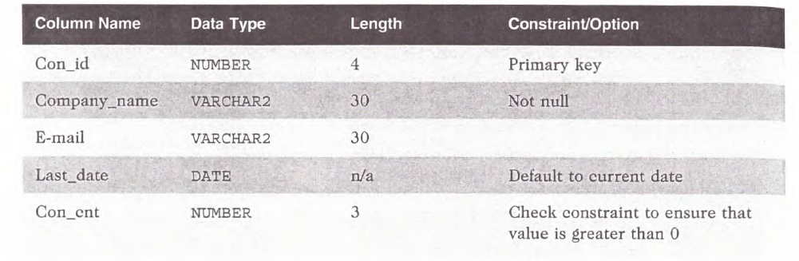

9. Add two rows of data to the table, using data values you create. Make sure the default option on the LAST—DATE column is used in the second row added. Also, issue a command to save the data in the table permanently.

10. Issue a command to change the e-mail value for the first row added to the table. Show a query on the table to confirm that the change was completed. Then issue a command to undo the change.